VPC CHALLENGE
- Design and deploy a scalable network architecture using AWS Transit Gateway to simplify network connectivity between multiple VPCs.
- First we need to create 3 Vpcs with subnets
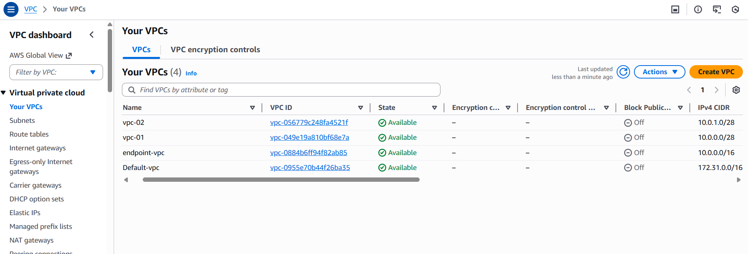
Then attach all internet gateways to each VPC
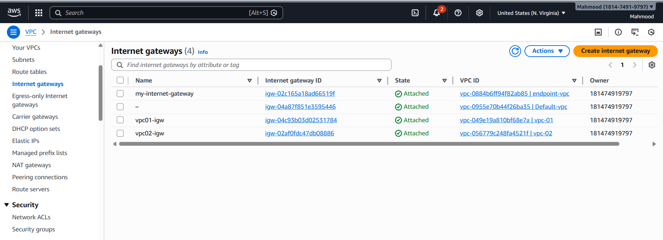
And create test Transit gateway and attach transit gateway attachment’s
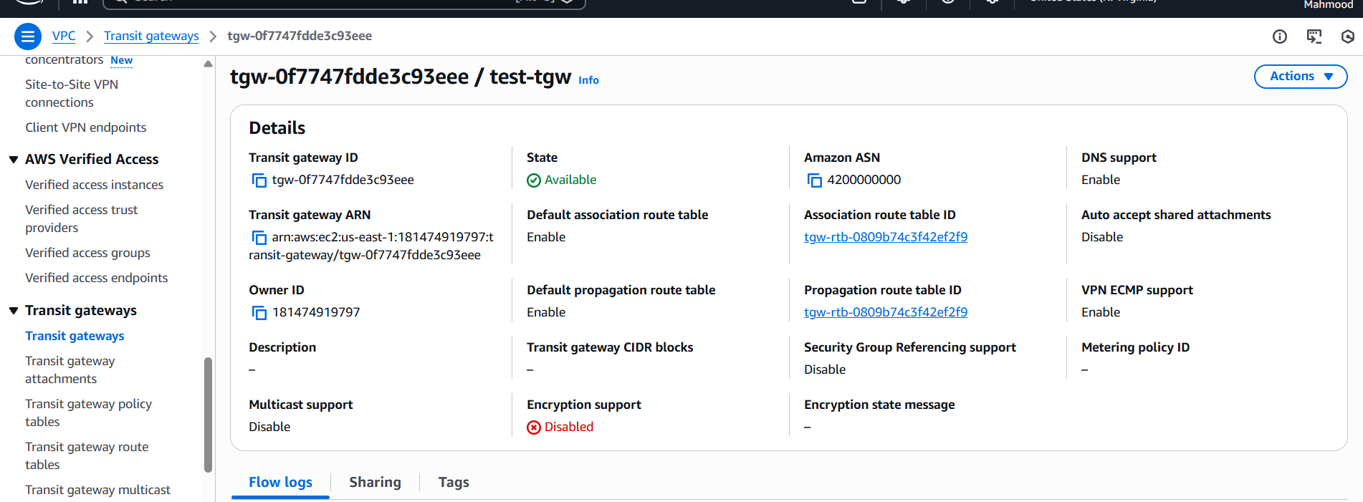
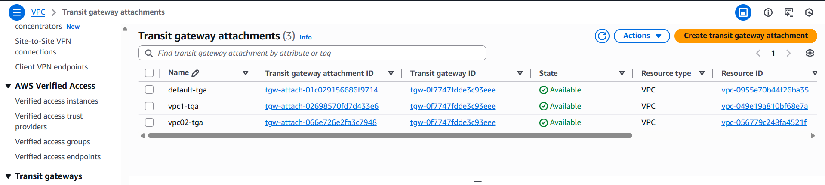
And provide route tables access to each VPC, edit routes and provide the route
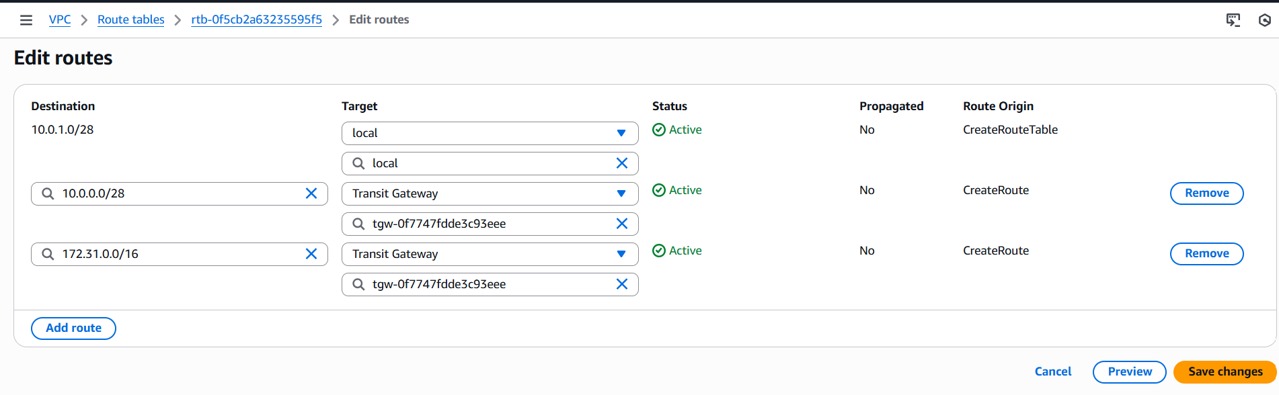
Now create 3 ec2 instances with each VPC
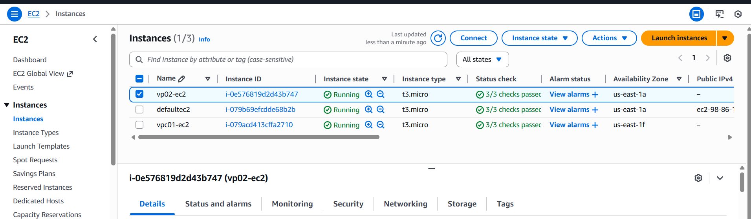
And provide connect ec2 in bash with public ip
ssh -i "Linux-all.pem" ec2-user@ec2-98-86-149-57.compute-1.amazonaws.com
and execute it with private ip
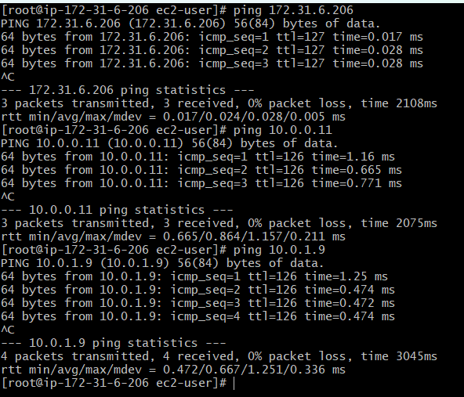

- Configure VPC endpoints to securely access AWS services without internet gateways or NAT gateways, ensuring data privacy and minimizing exposure to external threats.
